Nithin S
221IT085

IT302 Lab Assignment 1

Q1. Consider a set of integers from 1 to 100. Write a R/Python code to find the probability that the selected number is :

(a) Even

Code

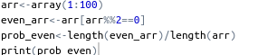

Output

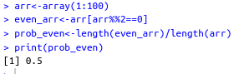

(b) Odd

Code

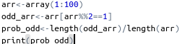

Output
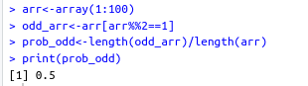

(c) Prime

Code
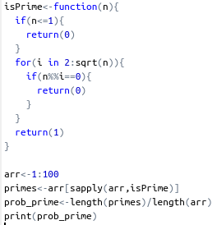

Output

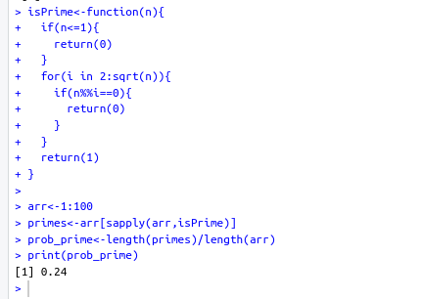

(d) Divisible by 4 and 6

Code
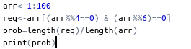

Output
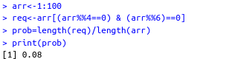

Q2. Suppose a fair dice is rolled 10 times. Using R/Python find the probability that

(a) sum of the numbers is less than 22

We follow monte carlo simulation to solve this question

Code
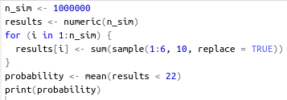

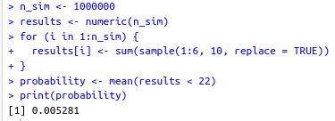
Output

(b) sum of the number is greater than 25

Code
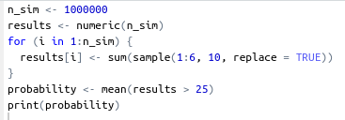

Output

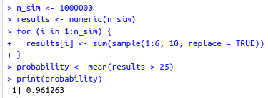

Q3. Suppose a family has sixteen children. Assume that is child is equally likely to be either a boy or a girl. Write a R/Python code to find the probability that

(a) Exactly six of the children are boys

Code

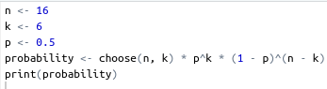

Output

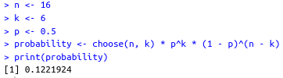

(b) Exactly eight of the children are girls

Code
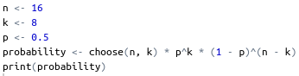

Output
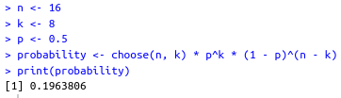

(c) There are 6 or 7 boys

Code
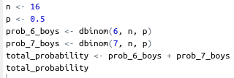

Output
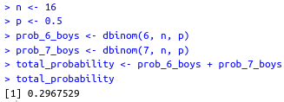

(d) The number of boys lies between the interval [7,12]

Note: I have assumed 7 and 12 are included

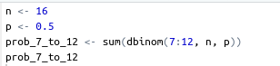
Code

Output

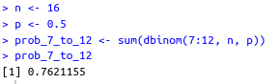

Q4. A box contains 10 white balls, 20 red balls, and 30 green balls. If 7 balls are drawn with replacement, write a R/Python code to find the probability that

(a) 4 white and 3 red balls appears

Code

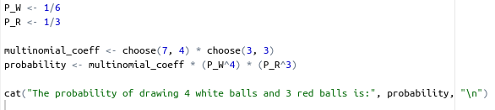

Output

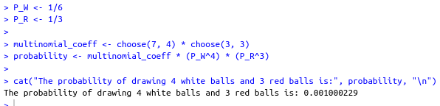
(b) All 7 are the same color

Code

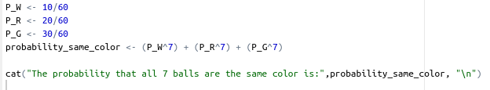

Output

